**CloudCraze Table Setup for Ruskin and Controls**

* **CC Storefront ERP**  
  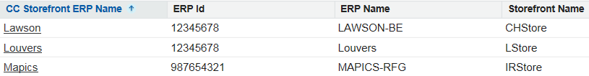
  + Proposed
    - CC Storefront ERP Name: “MacPac”
      * ERP Id: 12345678?, ERP Name: “MACPAC-R10”, Storefront Name: “RKStore”
    - CC Storefront ERP Name: “AOMS”
      * ERP Id: 12345678?, ERP Name: “AOMS-BE”, Storefront Name: “AOStore”
* **Bill To**
  + Proposed
    - Account Load updates this table to link Account to ERP Customer #
      * AR-Number
        + LAWSON-BE-?????????
        + MAPICS-RFG-????????
        + MACPAC-R10-??????
        + AOMS-BE-??????
    - Guest User setup for CHStore (existing)
      * Account: CCAnonymous
      * Bill To Name: JCI BP - Guest User Pricing
      * AR Number: LAWSON-BE-100111563
      * ERP Name: LAWSON-BE
      * ERP Account Id: 100111563
    - Guest User setup for RKStore (new for Louvers)
      * Account: CCAnonymous
      * Bill To Name: JCI BP - Guest User Pricing
      * AR Number: MACPAC-R10-??????
      * ERP Name: MACPAC-R10
      * ERP Account Id: ??????
    - Guest User setup for AOStore (new for Controls)
      * Account: CCAnonymous
      * Bill To Name: JCI BP - Guest User Pricing
      * AR Number: AOMS-BE-??????
      * ERP Name: AOMS-BE
      * ERP Account Id: ??????
* **CC ERP Number**
  + Proposed
    - Product Load updates this table to link CC Product to ERP SKU #
    - Link to “CC Storefront ERP Name” i.e. Lawson, Mapics, MacPac, AOMS
* **CC Account Group**
  + No proposed changes
  + Current Records
    - Anonymous
    - Portal Account
* **CC Account Group Price Lists**  
  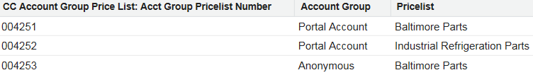
  + Proposed
    - Add 004254 for Portal Account Ruskin
    - Add 004255 for Portal Account Controls
* **CC Price Lists**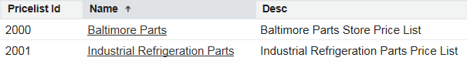
  + Proposed
    - Add 2002 for Ruskin
    - Add 2003 for Controls
* **CC Categories**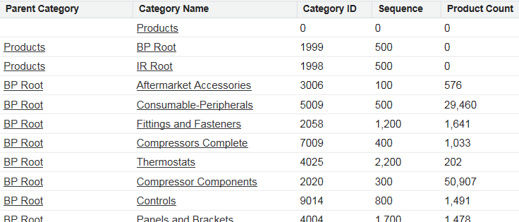
  + Proposed
    - Need to define and preload Parent/Child Categories
* **ERP Product Catg Xref**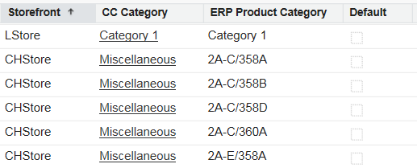
  + Proposed
    - Used to xref inbound products to storefront product categories
    - Must be preloaded before prior to loading or interfacing products